**Cryptocurrency Analysis**

This analysis examines the price trends, volatility, and risk-adjusted performance (Sharpe Ratios) of Bitcoin, Ethereum, and Ripple (XRP) over the past year. It also explores correlations between these cryptocurrencies to identify diversification opportunities and inform data driven investment strategies. By analyzing volatility and correlations, investors can better understand the risks and opportunities associated with these assets, particularly in the cryptocurrency market.

Volatility measures the extent of price fluctuations, making it a key indicator of risk for investors. It reflects how much the price of an asset varies over a specific period, with higher volatility indicating greater uncertainty and larger swings in value. For investors, understanding volatility is crucial because it directly impacts the risk and reward tradeoff in financial markets. Assets with high volatility can generate substantial profits during upward price movements but can also incur significant losses during downturns. Among the three cryptocurrencies analyzed, Ripple exhibited the highest volatility at **4.39%**, indicating its prices fluctuated more dramatically than those of Bitcoin or Ethereum. This heightened volatility may be attributed to several factors, including market speculation, regulatory uncertainty, and the asset's relatively smaller market capitalization compared to Bitcoin and Ethereum. Smaller market caps often result in lower liquidity, meaning that fewer trades can cause significant price movements. For investors, Ripple’s volatility represents both a risk and an opportunity, as rapid price changes can lead to substantial gains or steep losses in a short period. Ethereum followed with a volatility of **3.36%**, positioning it between Ripple and Bitcoin. Bitcoin, on the other hand, had the lowest volatility at **2.74%**, which is significant given its dominant position in the cryptocurrency market. As the largest and most widely adopted cryptocurrency, Bitcoin enjoys greater market capitalization and liquidity, which helps stabilize its price relative to other digital assets. Lower volatility, as seen with Bitcoin, typically suggests greater price stability, making it an attractive option for risk-averse investors who prioritize capital preservation over rapid gains. Institutions and conservative investors often favor Bitcoin as a "store of value," akin to digital gold, because it is perceived as less prone to sudden, dramatic price swings. Conversely, Ripple’s high volatility reflects its potential for significant gains or losses, making it a high-risk, high-reward option. For traders and speculative investors, such volatility can present lucrative short-term opportunities, especially when they can capitalize on price momentum. However, this also demands a higher tolerance for risk and a strategy to manage losses effectively, as extreme price swings can erode capital quickly. Understanding the causes and implications of volatility helps investors decide whether an asset aligns with their risk profile and investment goals.

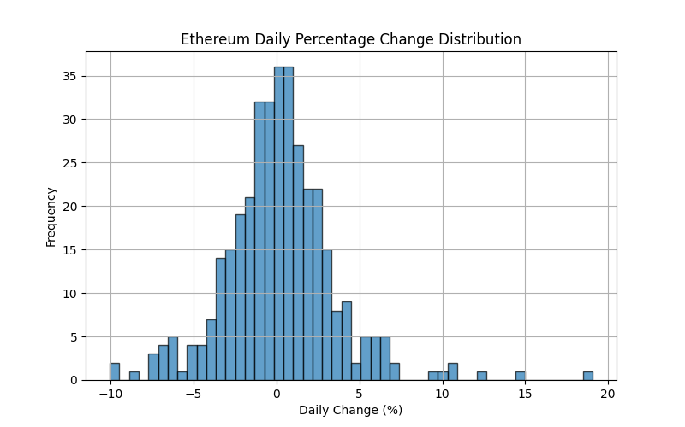

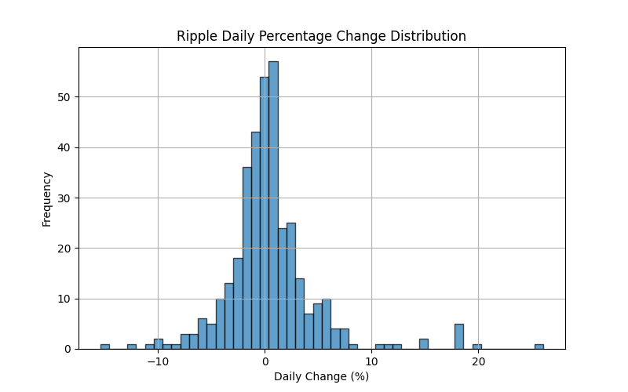

Risk adjusted performance, measured using the Sharpe Ratio, provides further insight into how each cryptocurrency performed relative to the assumed risk-free rate of **2%**. A negative Sharpe Ratio indicates that returns did not compensate for the level of risk taken. In this analysis, all three cryptocurrencies had negative Sharpe Ratios, with Ripple showing the least negative value at **-0.34**. Ethereum and Bitcoin followed at **-0.53** and **-0.62**, respectively. While all three underperformed compared to the risk free rate, Ripple’s smaller loss suggests slightly better performance on a risk adjusted basis.

The price trends of Bitcoin, Ethereum, and Ripple provide a clearer picture of their behavior over the past year. Bitcoin and Ethereum both exhibited steady price growth, punctuated by periodic declines, particularly in the middle of the year. Bitcoin’s price rose significantly in the final months, surpassing **$100,000**, signaling increased market confidence or external factors driving demand. Ethereum followed a similar pattern, with prices recovering strongly towards the year’s end.

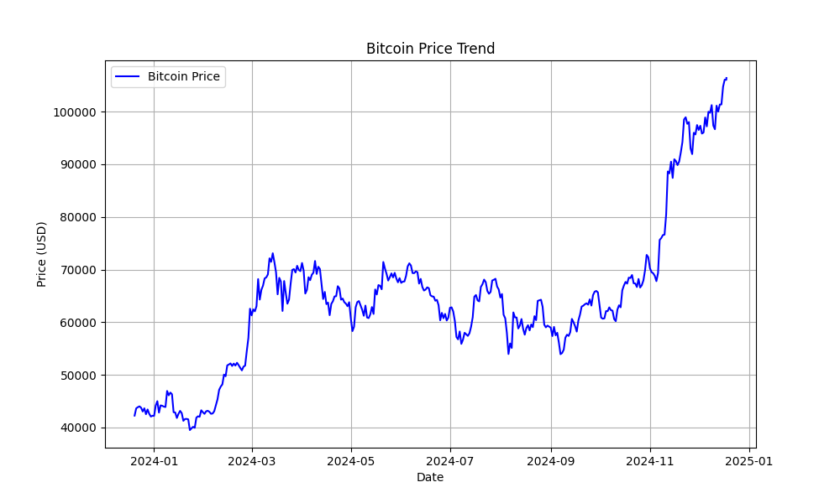

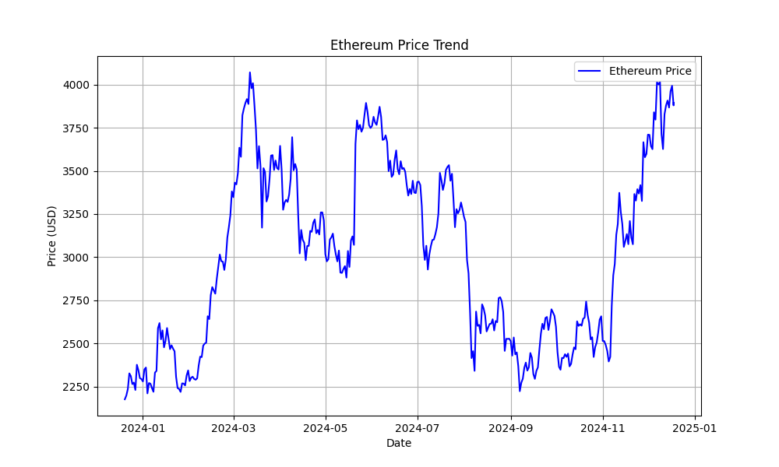

Ripple, in comparisont, showed a unique price trend. For much of the year, Ripple’s price remained relatively stable, fluctuating within a narrow range. However, it experienced a sudden and sharp upward spike in the final months, surpassing **$2.50**. This dramatic increase suggests a market event or surge in demand specific to Ripple, making it an intriguing asset for further investigation.

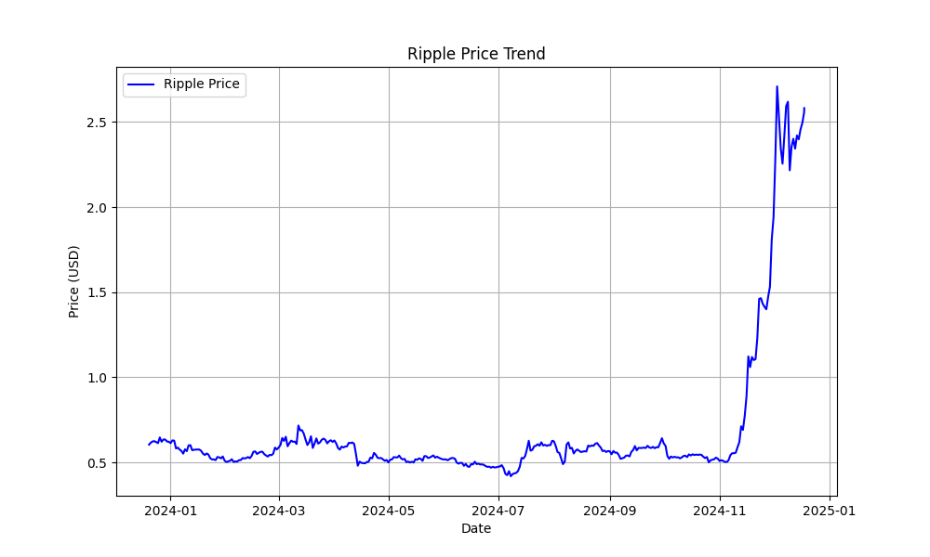

Understanding correlations between assets is essential for building a diversified portfolio. In this analysis, Bitcoin and Ethereum displayed a strong positive correlation of **0.79**, indicating that their prices tend to move in the same direction. This high correlation means that holding both assets may not provide significant diversification benefits, as they behave similarly in the market.

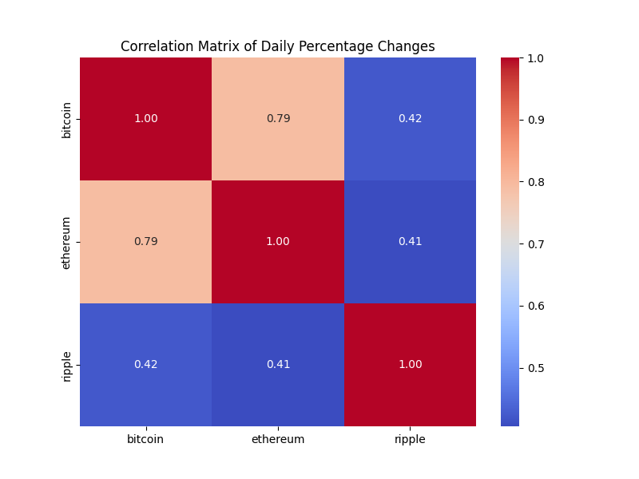

Ripple, on the other hand, demonstrated weaker correlations with Bitcoin (**0.42**) and Ethereum (**0.41**). This lower correlation suggests that Ripple’s price movements are more independent, making it a potential diversifier within a cryptocurrency portfolio. For investors looking to reduce portfolio risk, adding Ripple to a Bitcoin or Ethereum-heavy portfolio may help balance exposure to price fluctuations.

The findings of this analysis show key differences in the behavior of Bitcoin, Ethereum, and Ripple. Ripple’s high volatility and sharp price spike suggest it is a riskier but potentially more rewarding investment. In comparison, Bitcoin’s lower volatility makes it a more stable asset, appealing to those seeking reliability in the cryptocurrency market. Ethereum falls somewhere in between, combining moderate volatility with strong growth potential. The negative Sharpe Ratios across all three cryptocurrencies indicate that none of the assets outperformed the risk-free rate of **2%** over the analysis period. This result reflects broader market challenges or inefficiencies, which could be influenced by external economic conditions, investor sentiment, or regulatory factors. For those seeking stability, Bitcoin offers the lowest volatility, making it a safer option in a volatile market. Investors with a higher risk tolerance may consider Ripple, as its high volatility and recent sharp price increase present opportunities for substantial returns. Diversification is another critical takeaway. The strong correlation between Bitcoin and Ethereum suggests that holding both may not significantly reduce risk. By including Ripple, which has a weaker correlation with the other two assets, investors can achieve better diversification and potentially mitigate portfolio losses during market downturns. Finally, tracking metrics such as volatility, Sharpe Ratios, and correlations over time allows investors to adapt their strategies as market conditions change. Identifying trends, such as Ripple’s recent surge, can help with market timing and decision making, leading to more informed and effective investment strategies.

This analysis demonstrates Ripple’s volatility and diversification potential, while Bitcoin and Ethereum offer more stability but limited diversity due to their strong correlation. Despite negative Sharpe Ratios, the data provides valuable insights into the risk and return profiles of these cryptocurrencies. By understanding volatility, risk adjusted performance, and correlations, investors can make informed decisions to build balanced and resilient portfolios in the cryptocurrency market.